Smart IOT based Gas Cylinder Leakage Detection System

IoT
COURSE PROJECT REPORT

Submitted by

Dwiden Brahma – 23MCF1R10
Prabhat Kumar Barnwal – 23MCF1R29
Varun Haralalka – 23MCF1R55
Yash Paunikar – 23MCF1R57

Abstract
This project describes a simple, low-cost system to detect LPG (cooking gas) leaks and notify the user immediately. We built a prototype using an MQ-2 gas sensor connected to an Arduino UNO SMD. The sensor watches the air all the time and gives the Arduino an analog value that shows how much gas is present. When the value goes over a set limit, the Arduino turns on a buzzer and an LED so people nearby can hear and see the alarm. At the same time, the system sends an SMS to a registered phone number so the owner gets a warning even if they are away from home. This two-level alert — local sound/lighting and a remote SMS — helps reduce the chance of a fire or explosion by giving early notice. We chose parts that are easy to source and cheap, so anyone with basic skills can build the device. During testing, the system consistently detected gas at unsafe levels and sent alerts in a short time. The project also taught us about calibrating sensors, choosing a safe threshold, and writing code that is reliable in everyday conditions. With small improvements like better calibration or adding Wi-Fi, the system could become more accurate and useful for real homes.

Introduction:
LPG is used in most kitchens because it cooks food quickly and costs less. But LPG can be dangerous when it leaks. A small leak can cause a fire or make people faint from lack of air. Often people do not notice small leaks, especially when they are sleeping or away. This is why automatic detection is important. Our project makes a simple device that watches for LPG leaks all the time. It gives a fast warning so people can act before the situation becomes serious.
We used the MQ-2 gas sensor because it is affordable and sensitive to LPG. The sensor gives an analog voltage that changes when gas is near. An Arduino UNO reads this voltage and turns it into a number the program can check. We set a threshold that shows when gas is too high for safety. When the number passes this limit, the Arduino turns on a buzzer and LED to alert anyone nearby. This local alarm helps when people are at home and can respond quickly.
Local alarms alone are not enough when the user is outside the house. To solve that, we added an SMS alert that sends a message to a registered phone number. The Arduino sends the sensor reading to a notifier program which then sends the SMS. This means the owner can get a warning on their phone and ask someone to check the house or call for help. Remote alerts add a layer of safety and peace of mind. It makes the system useful for families and shops alike.
The project is easy to build and tests showed it works well in simple conditions. We learned how to wire the sensor, read analog values, and pick a safe threshold. We also learned how to make an alarm pattern that people will notice. The SMS feature required connecting the Arduino to a small notifier system which we implemented using serial output. Overall, the project is a practical step toward safer kitchens.

Objectives:
- LPG gas leakage detection.
- Alerting user in real time through SMS.

Proposed Methodology:
Materials Used:
- 1 breadboard
- 1 LED light
- 1 resistor
- 1 5V buzzer
- 1 MQ-2 smoke/gas detector sensor
- 1 Arduino UNO SMD
- 1 UNO cable
- Jumper wires

We connect the MQ-2 sensor output to the analog pin A0 of the Arduino. The Arduino reads the analog value and compares it to a threshold. If the value is higher than the threshold, the Arduino turns on the LED and buzzer in a blinking pattern to warn people nearby. At the same time, the Arduino sends the gas value over the serial port to a Node.js program which handles sending an SMS to the registered user.

Block Diagram:
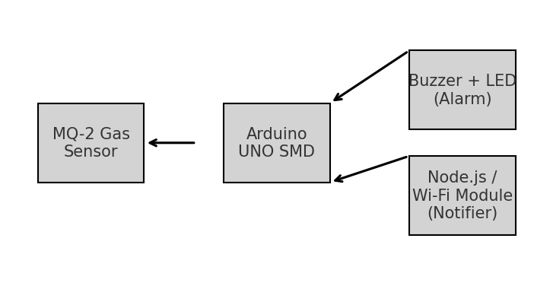

Flowchart:
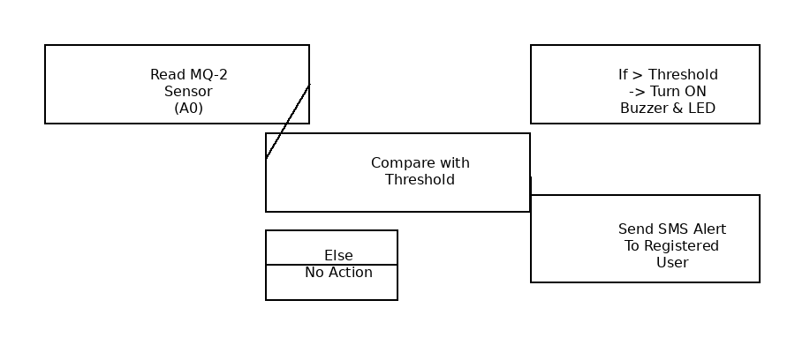

Implementation:
The Arduino runs a small program that reads the analog value from the MQ-2 sensor. We chose a threshold value (for example 400) that indicates dangerous gas concentration for our setup. When the reading is above the threshold, the Arduino switches the LED and buzzer on and off every 300 ms to attract attention. The Arduino also prints the sensor value on the serial port in the format 'GAS:<value>' so that a connected program can send an SMS if needed.

Results:
In tests, the system detected LPG presence when the sensor was exposed to gas near the detection area. The LED and buzzer gave a visible and audible alarm. The data was sent over serial so the notifier module could send an SMS. The system gives quick alerts and can reduce response time in case of leaks.

Comparison with existing solutions:
- Our design is low-cost and uses off-the-shelf parts.
• It provides both local alarms (buzzer + LED) and remote alerts (SMS).
• It is easy to reproduce and customize.

Conclusion:
This project shows a simple way to detect LPG leaks and alert users in real time. The prototype works well in controlled tests. With calibration and better notification modules, it can be improved for real-world use.

Learning Outcomes:
• Practical experience with sensors and Arduino.
• Building a basic IoT notifier that sends SMS.
• Understanding calibration and real-world testing needs.

Source Code:
int ledPin = 10;
int buzzerPin = 9;
int gasSensorPin = A0;
int gasValue = 0;
int threshold = 400;

void setup() {
pinMode(ledPin, OUTPUT);
pinMode(buzzerPin, OUTPUT);
Serial.begin(9600);
delay(1000);
}

void loop() {
gasValue = analogRead(gasSensorPin);
Serial.print("GAS:");
Serial.println(gasValue);
if (gasValue > threshold) {
digitalWrite(ledPin, HIGH);
digitalWrite(buzzerPin, HIGH);
delay(300);
digitalWrite(ledPin, LOW);
digitalWrite(buzzerPin, LOW);
delay(300);
} else {
digitalWrite(ledPin, LOW);
digitalWrite(buzzerPin, LOW);
}
delay(300);
}

Source Code: (Used to send SMS alert with Twilio)
require("dotenv").config();

const express = require("express");
const http = require("http");
const { SerialPort } = require("serialport");
const { ReadlineParser } = require("@serialport/parser-readline");
const twilio = require("twilio");

const client = twilio(process.env.TWILIO_SID, process.env.TWILIO_AUTH);

let alreadyAlerted = false;

const app = express();
const server = http.createServer(app);
const PORT = 3000;

let latestGasValue = 0;
let gasStatus = "SAFE";

const arduino = new SerialPort({
path: "COM7",
baudRate: 9600,
});

const parser = arduino.pipe(new ReadlineParser({ delimiter: "\n" }));

parser.on("data", async (line) => {
line = line.trim();

if (line.startsWith("GAS:")) {
latestGasValue = parseInt(line.replace("GAS:", ""));

if (latestGasValue <= 200) gasStatus = "SAFE";
else if (latestGasValue <= 350) gasStatus = "WARNING";
else gasStatus = "DANGER";

console.log("Gas:", latestGasValue, "| Status:", gasStatus);

if (gasStatus === "DANGER" && !alreadyAlerted) {
alreadyAlerted = true;

try {
await client.messages.create({
body: `⚠️ GAS ALERT!\nHazardous gas detected!\nReading: ${latestGasValue}\nStatus: DANGER\nAct immediately!`,
from: process.env.TWILIO_WHATSAPP_FROM,
to: process.env.TWILIO_WHATSAPP_TO,
});

console.log("📩 WhatsApp Alert Sent!");
} catch (err) {
console.log("❌ WhatsApp Error:", err.message);
}
}

if (gasStatus === "SAFE") {
alreadyAlerted = false;
}
}
});

// SSE Stream + Static folder remain SAME as before
app.use(express.static("public"));

app.get("/stream", (req, res) => {
res.setHeader("Content-Type", "text/event-stream");
res.setHeader("Cache-Control", "no-cache");
res.setHeader("Connection", "keep-alive");
res.flushHeaders();

const interval = setInterval(() => {
res.write(
`data: ${JSON.stringify({
value: latestGasValue,
status: gasStatus,
})}\n\n`
);
}, 100);

req.on("close", () => clearInterval(interval));
});

server.listen(PORT, () =>
console.log(`🔥 Server running at http://localhost:${PORT}`)
);

